**SEMESTER PROJECT OOP**

**GROUP MEMBER:**

* **SAIFULLAH (SP21-BSE-022)**
* **ABDUL RAFFAY (SP21-BSE-036)**

**BSE-3B**

**PROJECT NAME:**

**TEXT EDITOR IN JAVA**

**---------------------------------------------------------------------------------------------------**

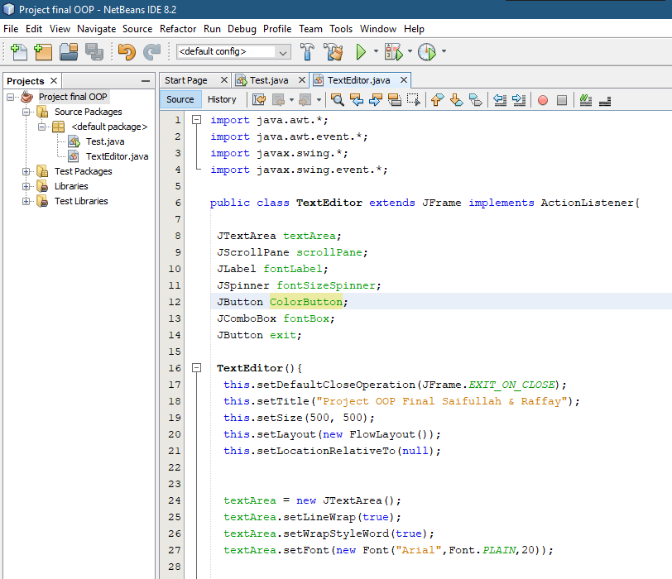

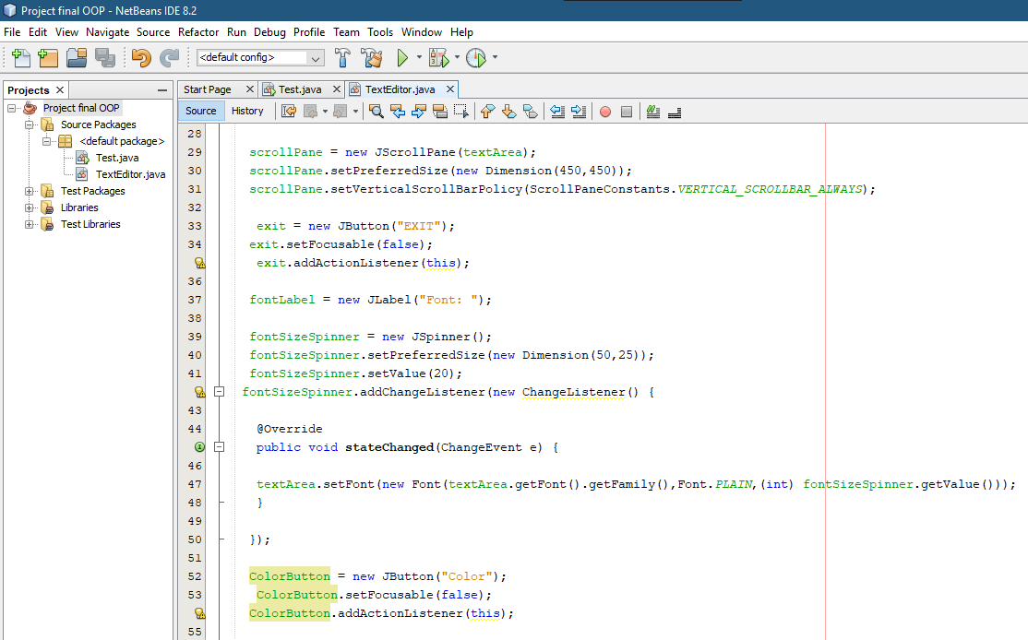

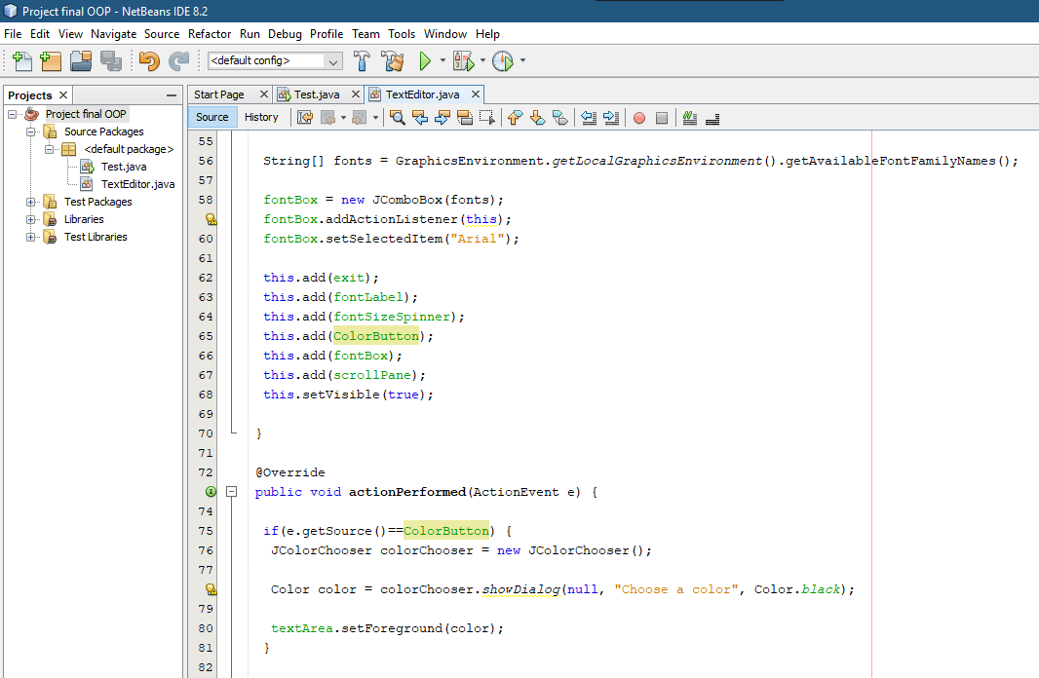

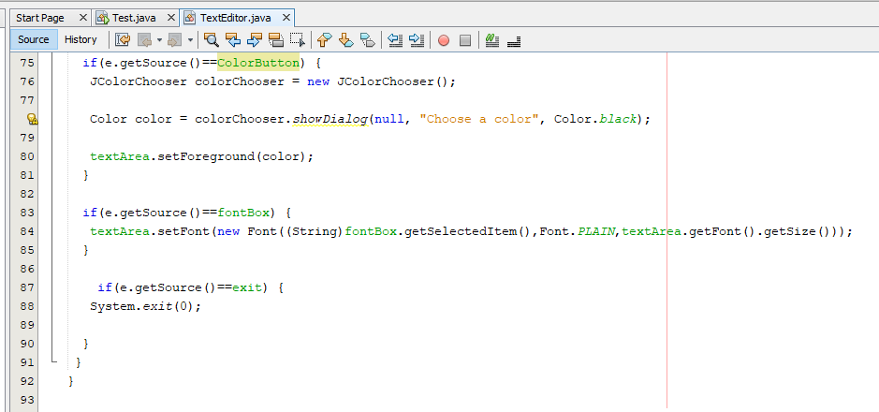

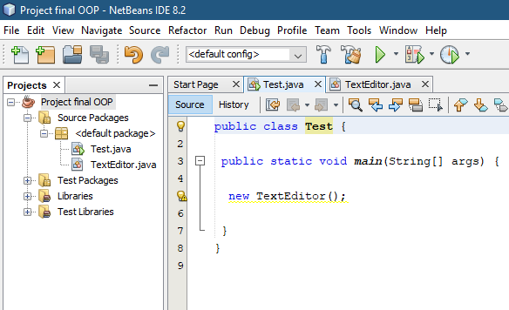

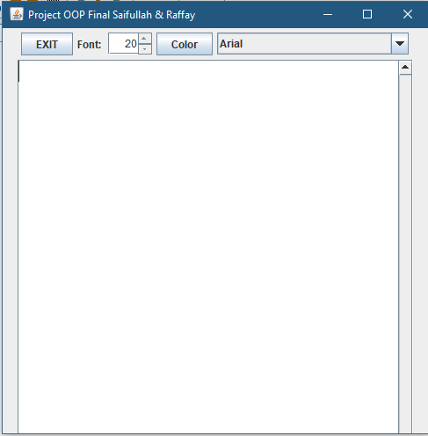

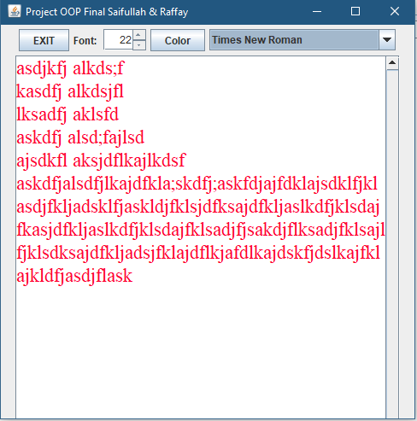

---------------------------------------------------------------------------------------------------------------------

**CLASS DIAGRAM:**

|  |
| --- |
| JFrame |
|  |
|  |

|  |
| --- |
| ActionListener |
|  |
| + actionPerformed(e : ActionEvent ): void  + stateChanged (e : ChangeEvent): void |

|  |
| --- |
| TextEditor |
| +textArea: JTextArea  +scrollPane: JScrollPane  +fontLabel: JLabel  +fontSizeSpinner: JSpinner  +ColorButton: JButton  +fontBox: JComboBox  +exit: JButton |
| +TextEditor()  + actionPerformed(e : ActionEvent ): void  + stateChanged (e : ChangeEvent): void |

|  |
| --- |
| Test |
|  |
|  |